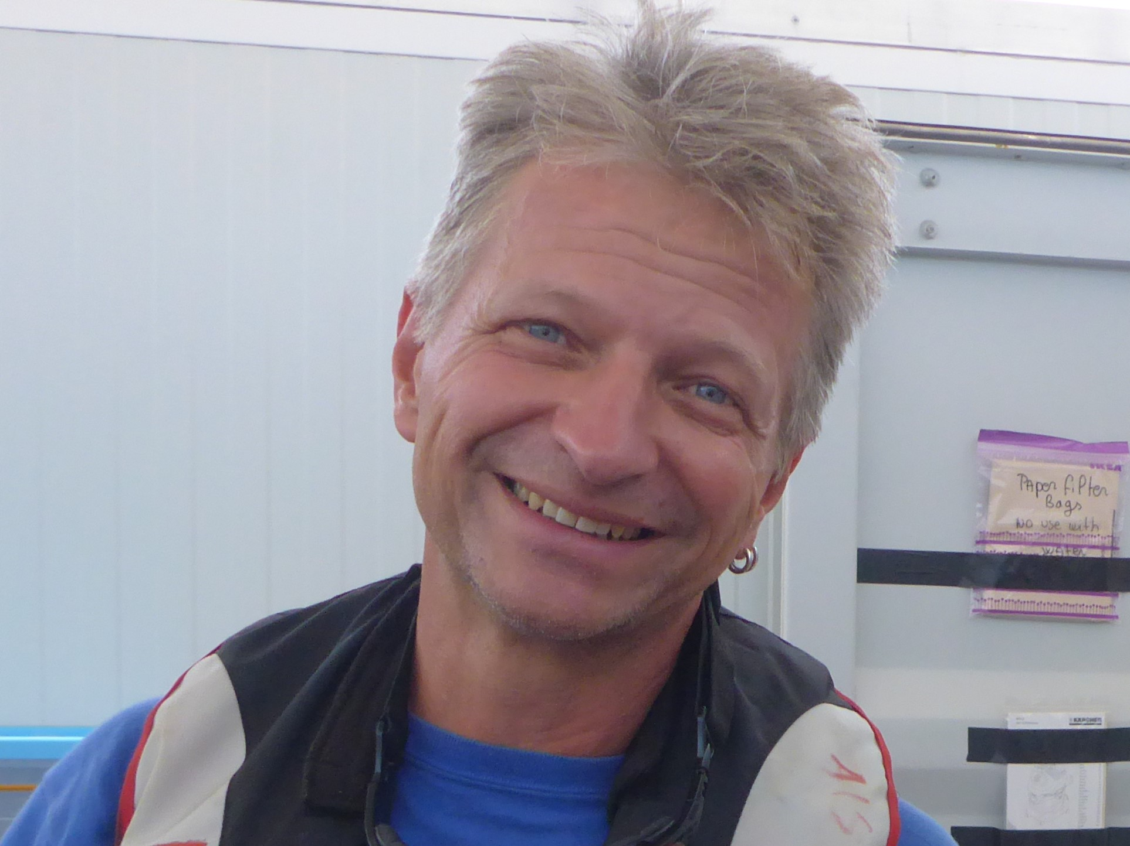
Photo: taken at a SAR mission in the Mediterranean

Frank Dörner lived in Hamburg before he moved to Berlin 1987. Frank studied human medicine at the Free University of Berlin, specialised in general medicine and gained a doctorate in the field of tropical medicine. Today he works as General Practitioner in Berlin Wedding, teaches Humanitarian Medicine in a private university and engages strongly in humanitarian situations.
He started working in the field of Humanitarian Action with Médecins Sans Frontières (MSF) in 1998 and went for several years overseas to work in health projects. From 2008-2014 he was General Director of MSF Germany. His last MSF project was in Sierra Leone to coordinate the medical work on Ebola end of 2014.
In 2015 he became part of „SeaWatch“, a private organisation involved in rescue of refugees in the Mediterranean. Frank is a founding member of Sea Watch and went several times as doctor on board of the rescue ships to assist people in distress close to Libya. The Sea Watch assisted and rescued since 2015 over 35.000 people and made strong demands for urgently needed increase of rescue activities public. The organisation stands for direct action and political challenge through innovative approaches and demands # safe passage!

